BLADDER CANCER AWARENESS MONTH

Copyable and shareable posts to use throughout Bladder Cancer Awareness Month.

Post | Facebook and LinkedIn Graphic
Bladder cancer affects thousands of people every year, yet many still think it’s uncommon. The reality? It’s one of the 10 most common cancers in the UK. Know the signs. https://actionbladdercanceruk.org/symptoms/ #BladderCancerAwarenessMonth | 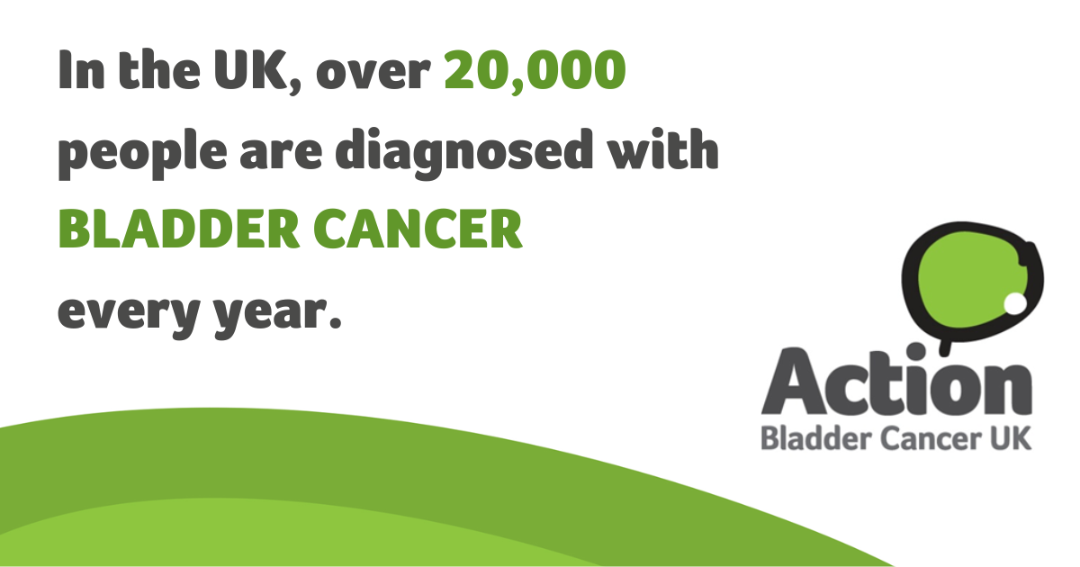
🩸 Blood in your urine, 🚽a persistent or recurrent, urgent or frequent need to wee,⚡ pelvic pain or discomfort could all be signs of #BladderCancer. If you notice symptoms, don’t wait: see your GP for advice. Find out more: https://actionbladdercanceruk.org/symptoms/ #BladderCancerAwarenessMonth | 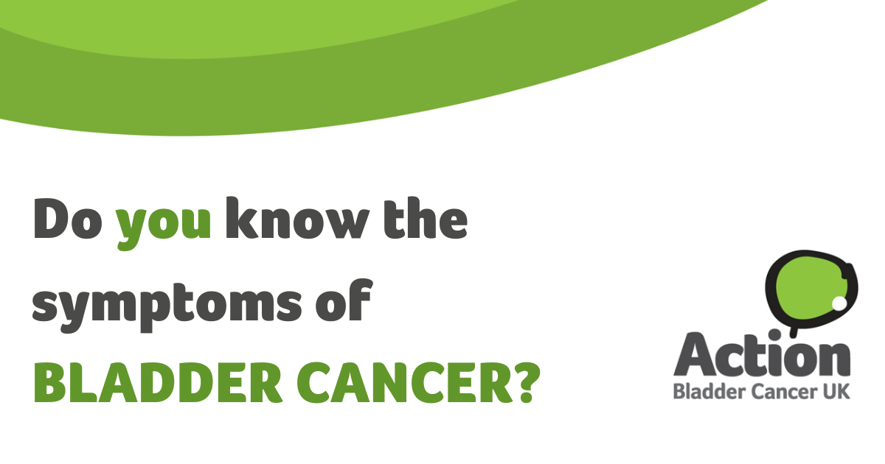
The most common symptom of #BladderCancer is blood in your urine (even just once). It’s usually bright red, but sometimes rusty or dark brown. You may also see blood clots. Find out more: https://actionbladdercanceruk.org/symptoms/ #BladderCancerAwarenessMonth | 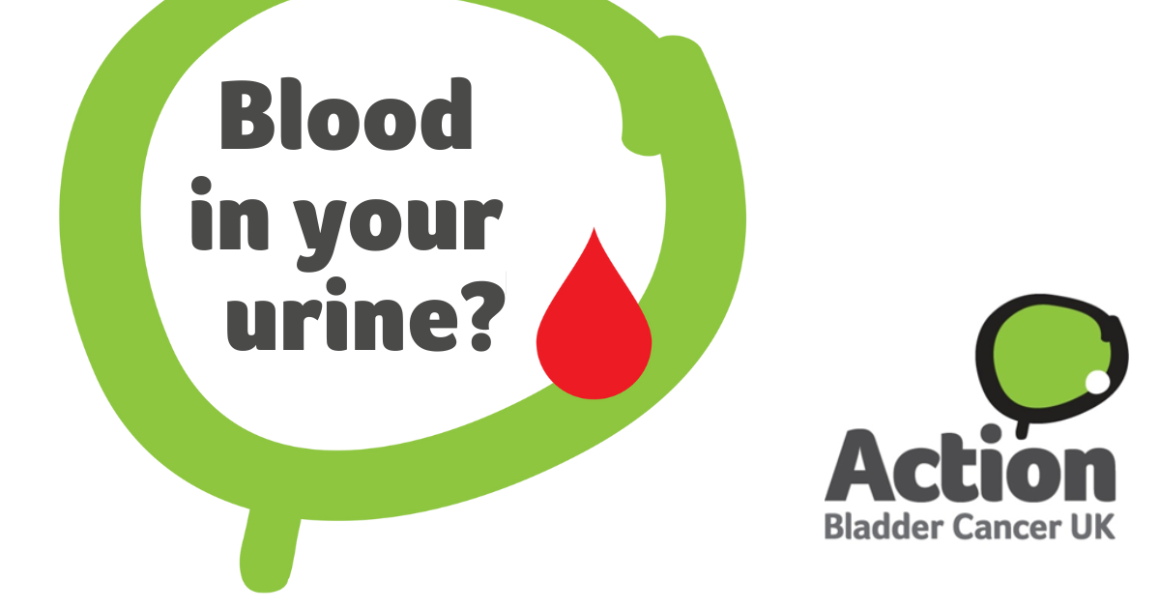
Experiencing the persistent or recurrent, frequent or urgent need to wee? These could be signs of #BladderCancer. Don't ignore them - visit your GP for advice. Learn more: https://actionbladdercanceruk.org/symptoms/ #BladderCancerAwarenessMonth | 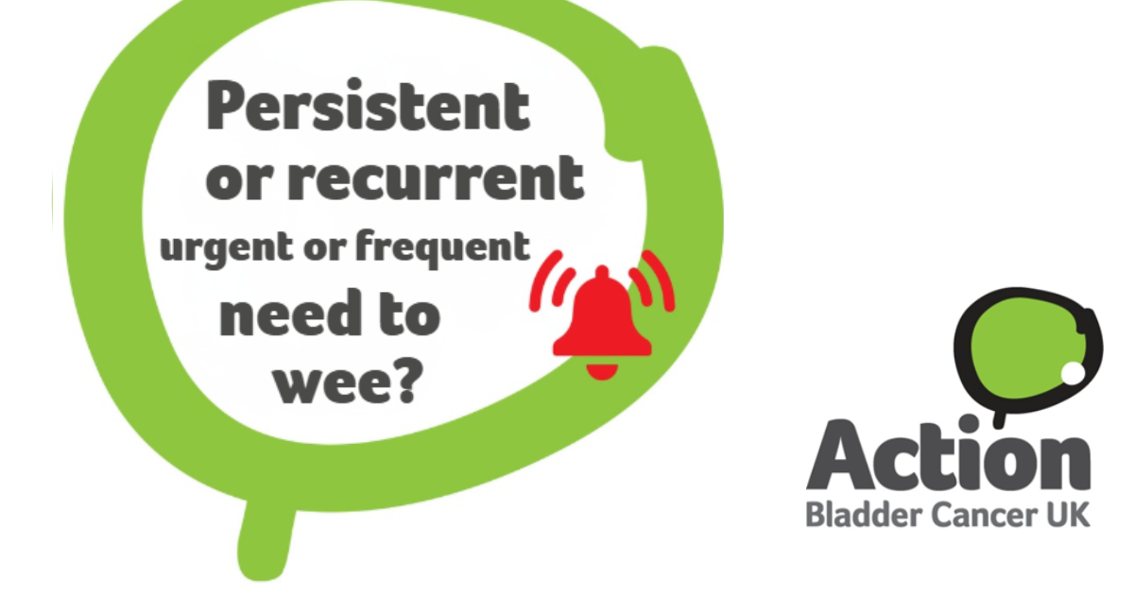
One patient described having a nagging intermittent pain in his lower back. Pelvic pain or discomfort could be a sign of #BladderCancer. If something doesn’t feel right, see your doctor. Find out more: https://actionbladdercanceruk.org/symptoms/ #BladderCancerAwarenessMonth | 
#BladderCancer is often diagnosed late leading to more difficult treatments and potentially poorer outcomes. Being aware of the symptoms could make all the difference. Find out more: https://actionbladdercanceruk.org/symptoms/ #BladderCancerAwarenessMonth | 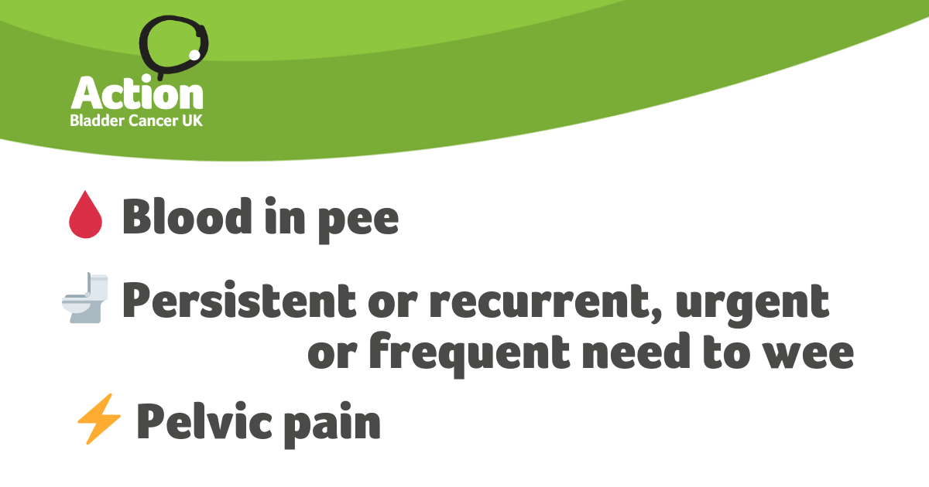
#BladderCancer symptoms can be mistaken for UTIs or gynaecological issues, especially in women. If your GP diagnoses a UTI after spotting blood in your urine, ask if the urine test did confirm an infection or if more tests are needed to rule out bladder cancer. Find out more : https://actionbladdercanceruk.org/about-bladder-cancer/ #BladderCancerAwarenessMonth | 